Project Report
Team id: PNT2022TMID01080
(Please view the report in web layout mode)
- INTRODUCTION

  - Project Overview:
Railways have been an essential mode of transportation for people all over the world for centuries. Indian Railways is the second largest Railway system in the world. Providing a smart solution for railways is a fantastic task. Railway operators around the globe are implementing IoT-enabled solutions to create intelligent, connected railways today.

  - Purpose:
Creating a passenger-friendly environment for railway needs will improve the quality of service. Providing a smart solution for railways using smart sensors will reduce the work of manually checking the cracks in tracks. Our ultimate goal is to facilitate the passenger by all means.

- LITERATURE SURVEY

  - Existing problem:
Existing train tracks are manually researched. LED (Light Emitting Diode) and LDR (Light Dependent Resister) sensors cannot be implemented on the block of the tracks. The input image processing is a clamorous system with a high cost and does not give the exact result. The Automated Visual Test Method is a complicated method as the video color inspection is implemented to examine the cracks in rail track which does not give accurate result in bad weather. This traditional system delays transfer of information.

  - References:

1) S. Mishra, A. Shrivastava and B. Shrivastav, “A Smart Fault Detection System For Indian Railways”, International Journal of Scientific & Technology Research, 2019. 2) S. Ramesh, “Detection of Cracks and Railway Collision Avoidance System”, International Journal of Electronic and Electrical Engineering ISSN 0974- 2174 Volume 4 (3), pp. 321-327, 2011. 3) T. Wang, F. Yang, K-L. Tsui, “Real-Time Detection of Railway Track Component via One-Stage Deep Learning Networks”. Sensors, 20, 4325, 2020. 4) Retrieved from- https://www.rototron.info/raspberry-pi-stepper-motortutorial/

  - Problem Statement Definition:
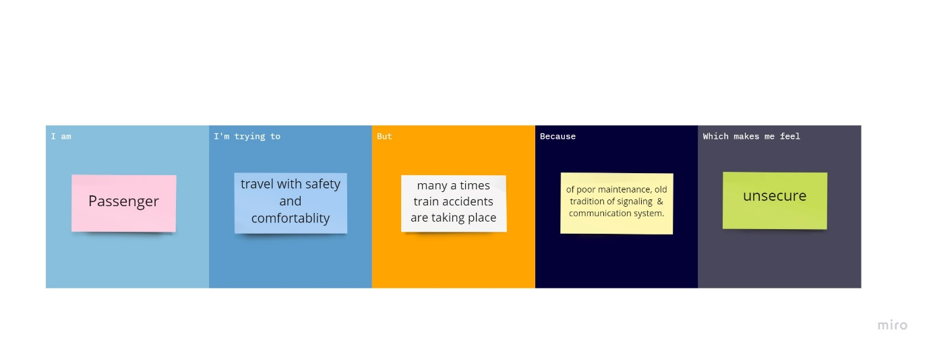

- IDEATION & PROPOSED SOLUTION

  - Empathy Map Canvas:

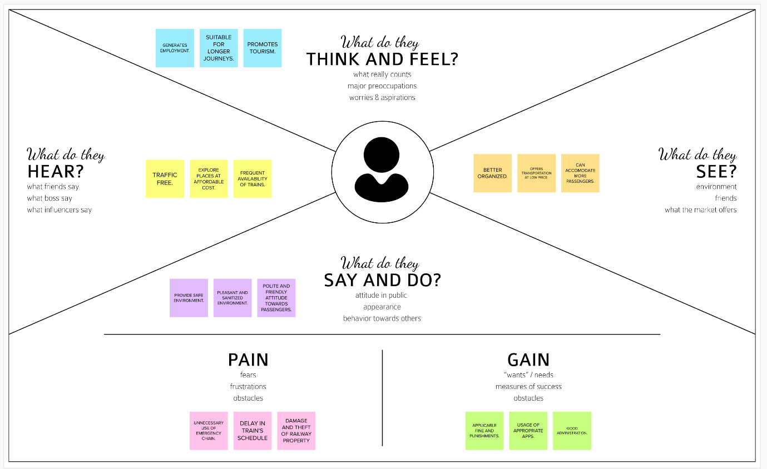

  - Ideation & Brainstorming

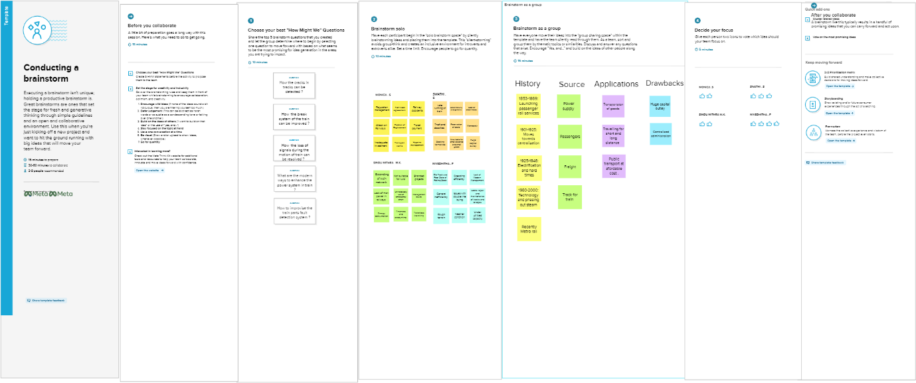

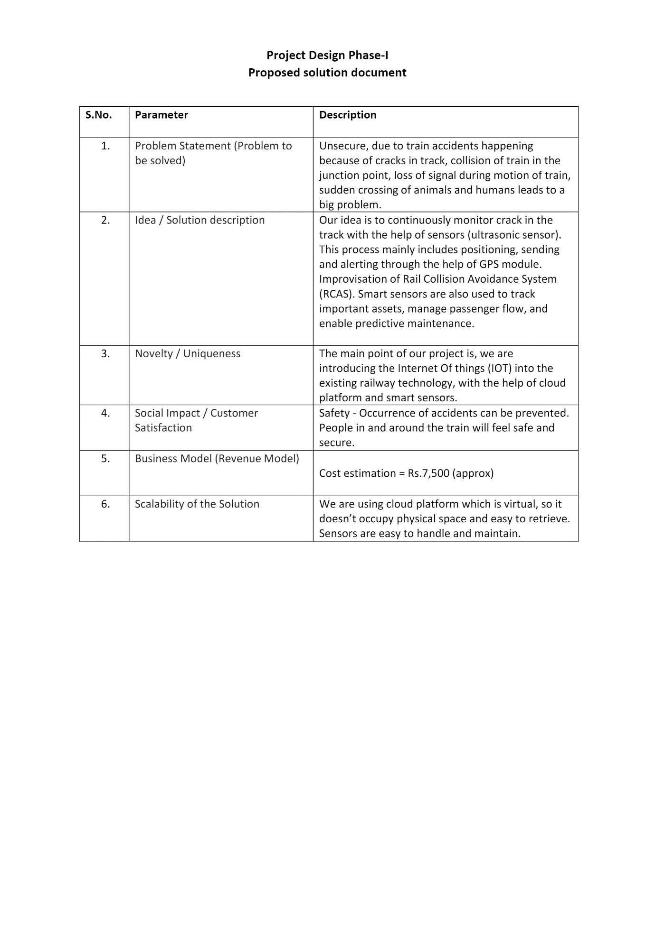
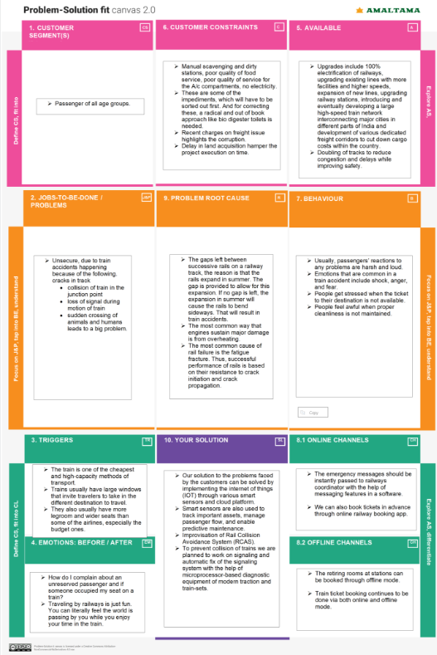
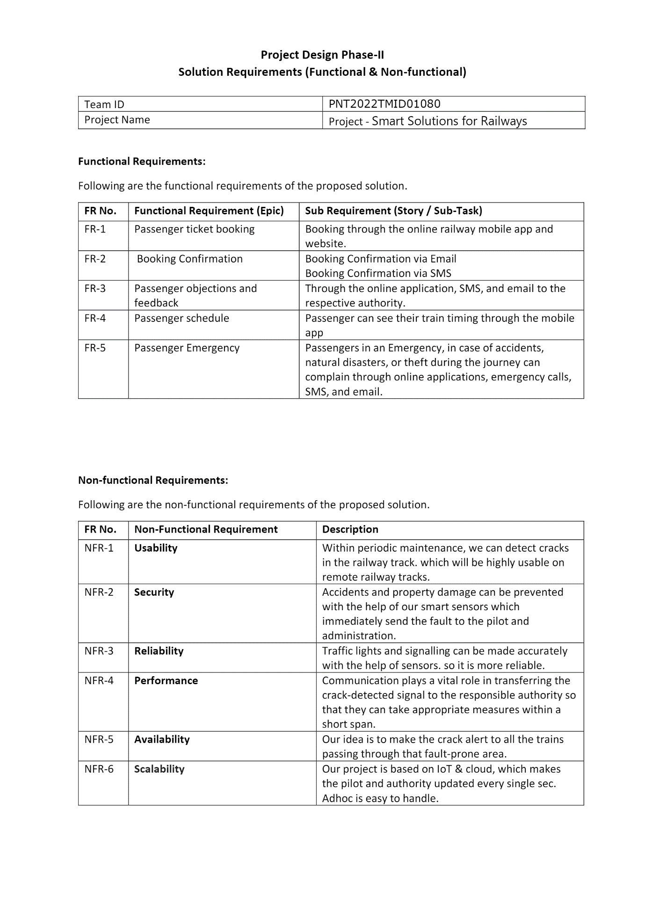

- PROJECT DESIGN
  - Data Flow Diagrams

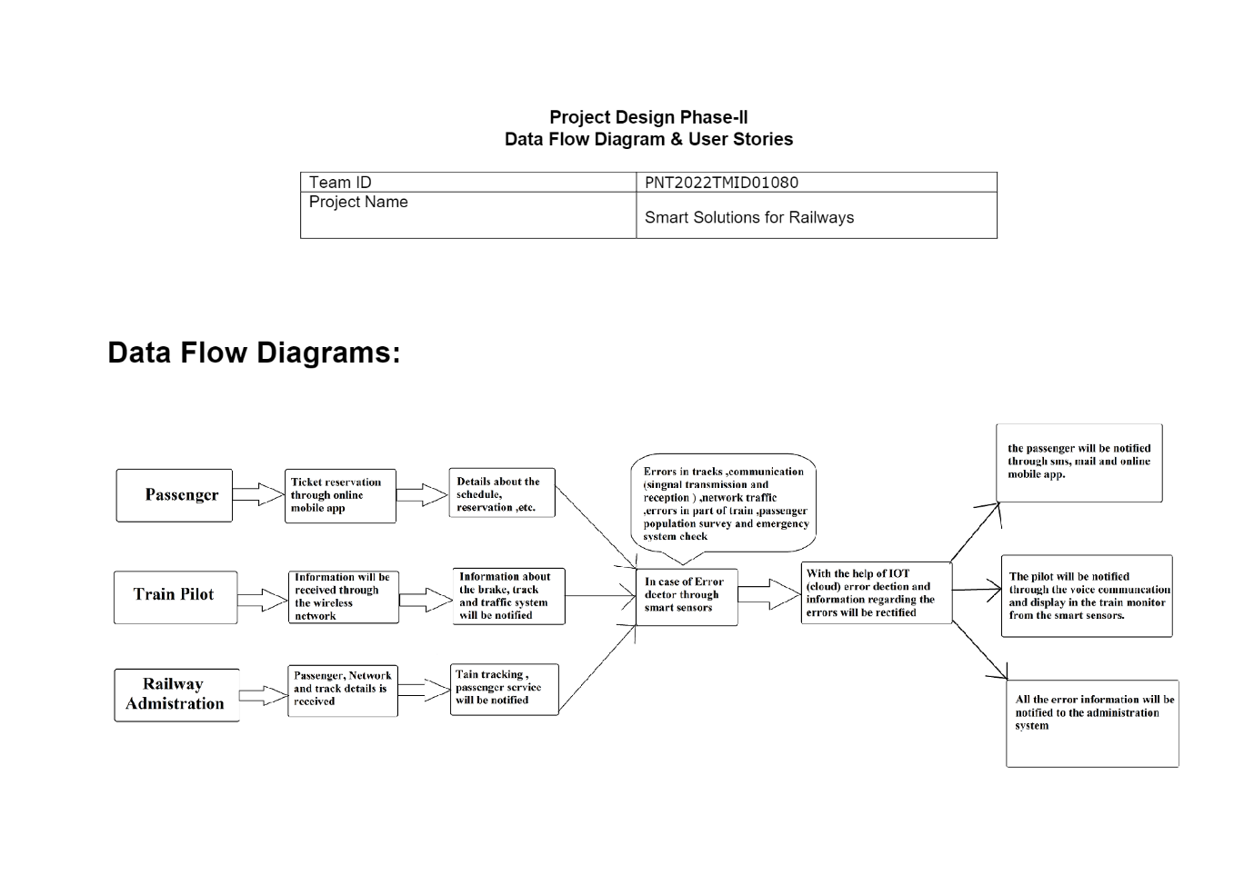
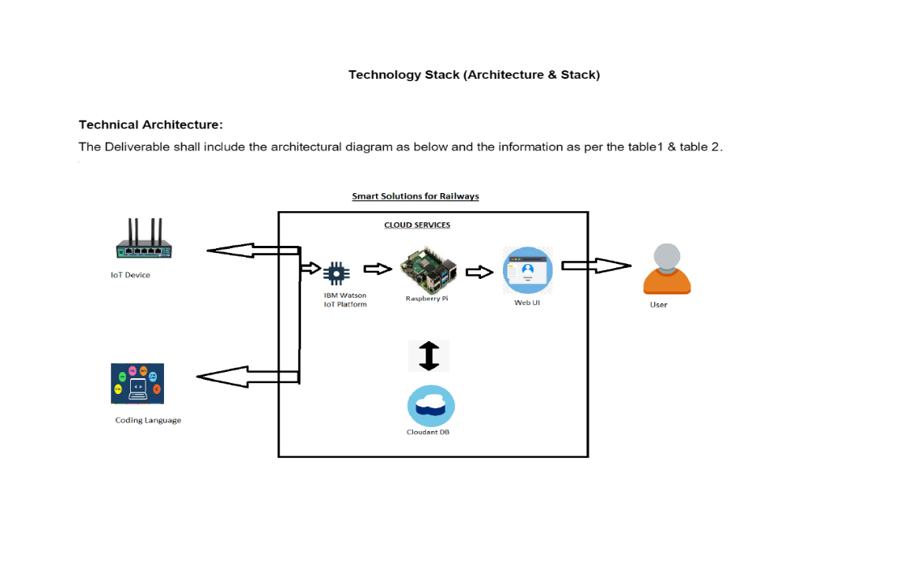

  - Solution & Technical Architecture
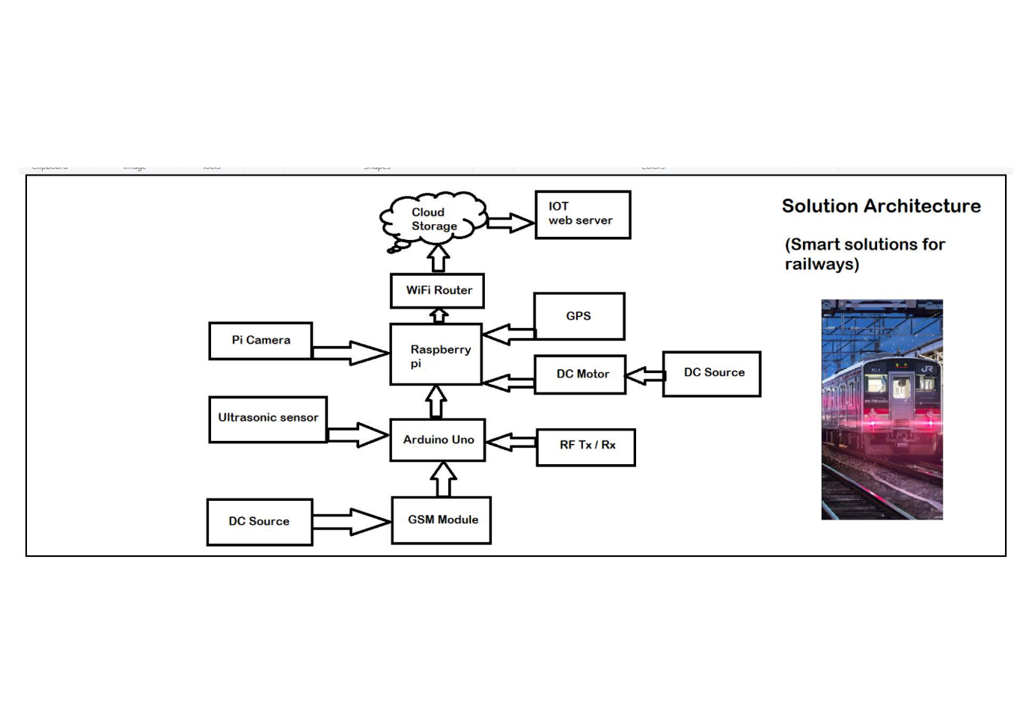
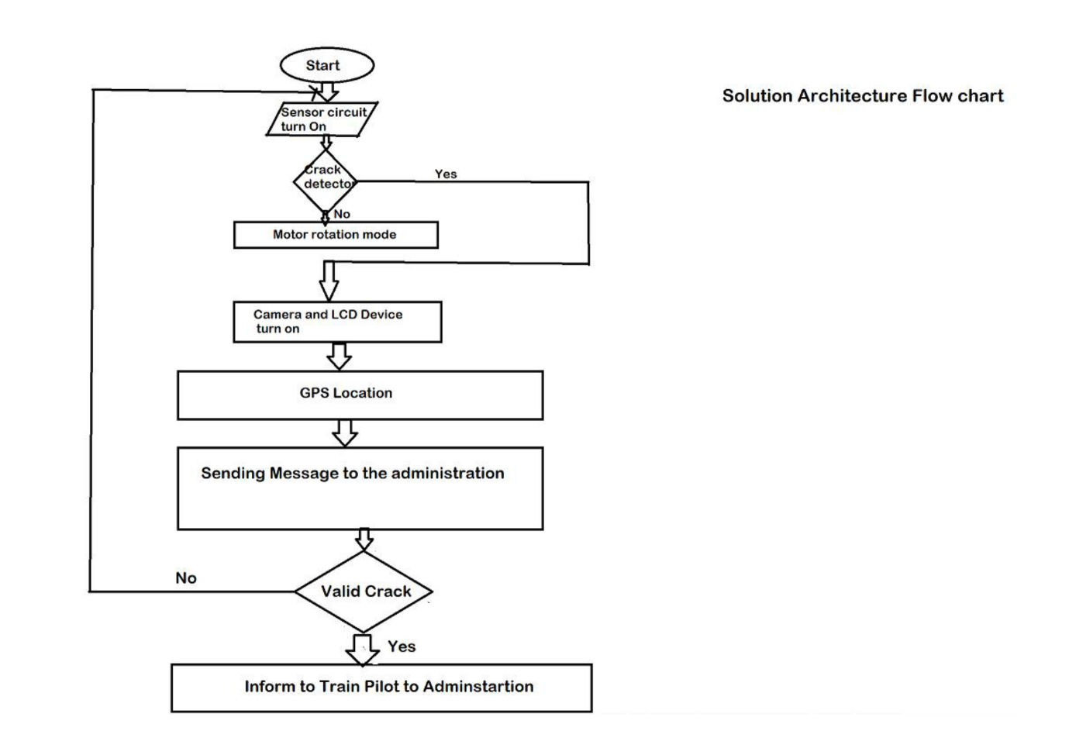

  - User Stories
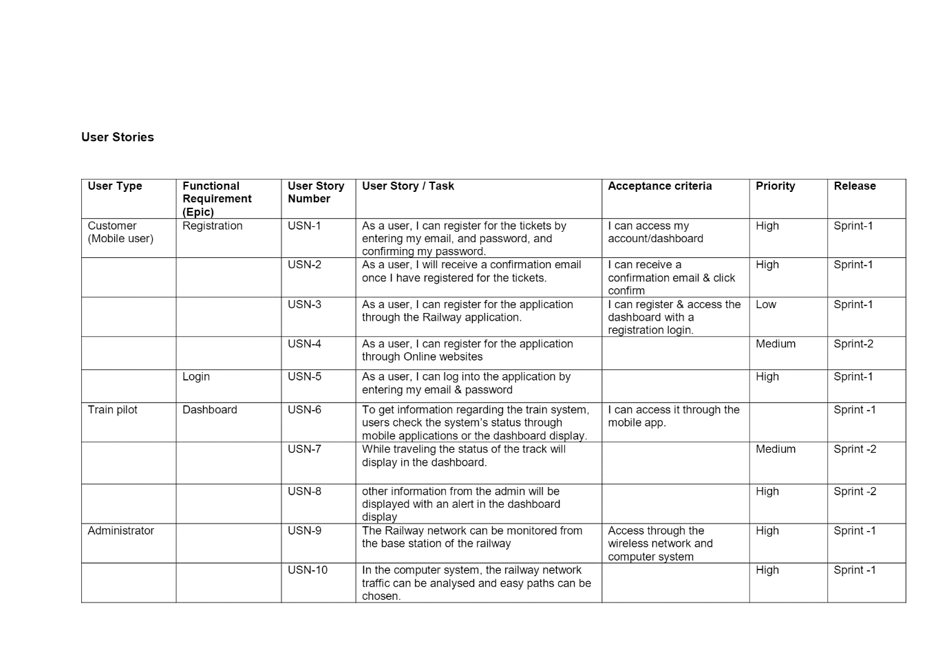

- PROJECT PLANNING & SCHEDULING
  - Sprint Planning & Estimation
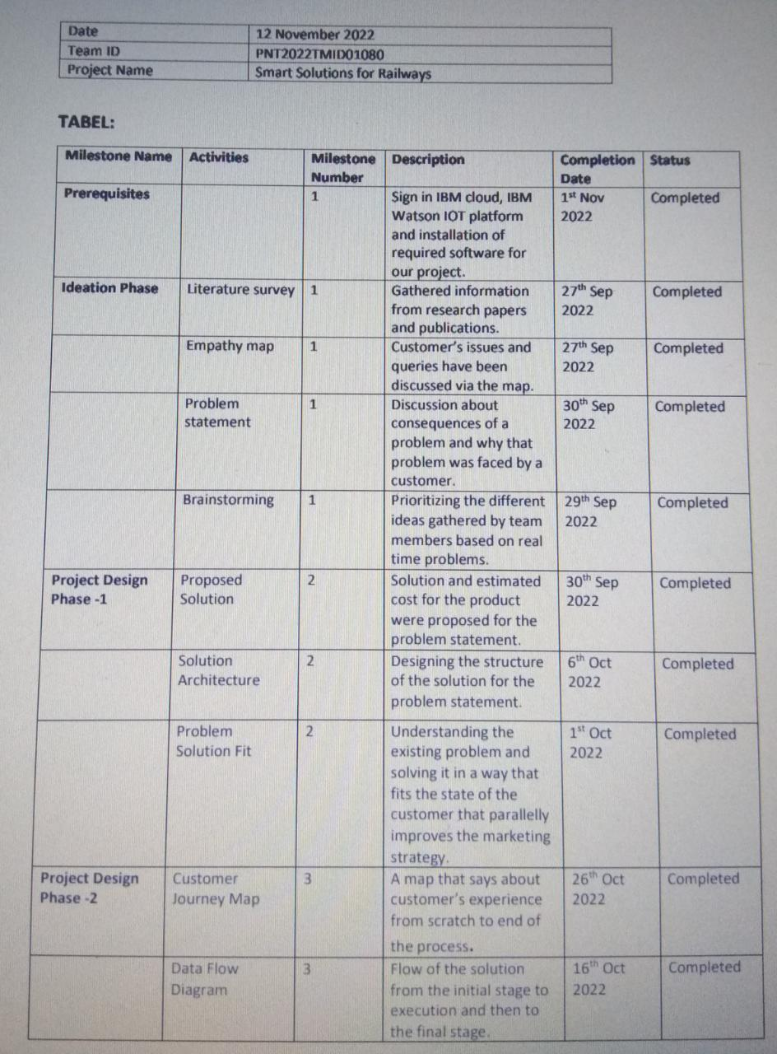

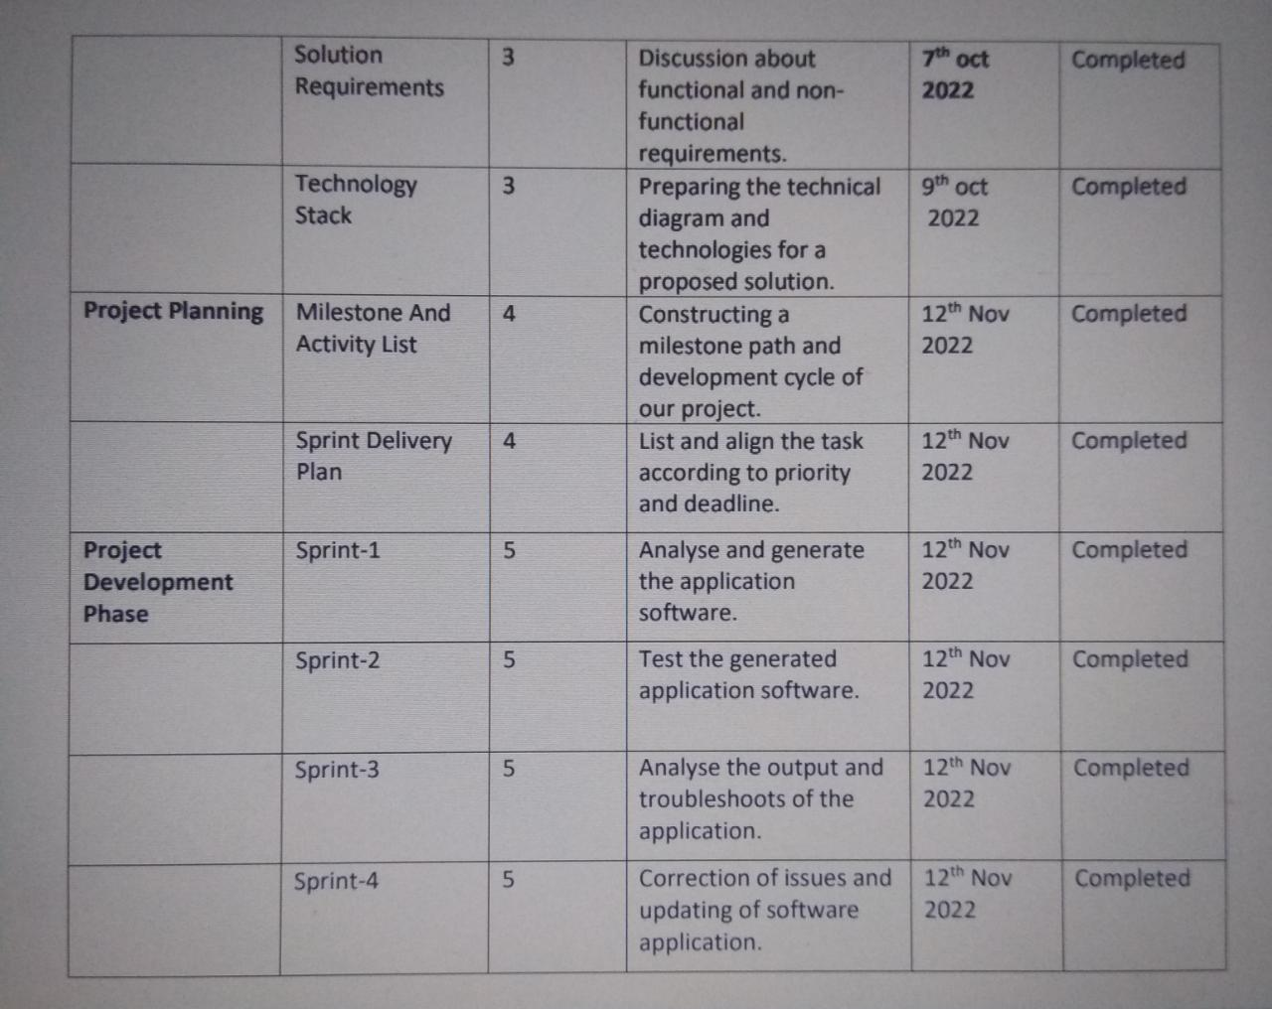

  - Sprint Delivery Schedule

Project Planning Phase
Project Planning Template (Product Backlog, Sprint Planning, Stories, Story points)

Team ID | PNT2022TMID01080
Project Name | Smart Solutions for Railways

Product Backlog, Sprint Schedule, and Estimation (4 Marks)

Sprint | Functional  Requirement (Epic) | User Story  Number | User Story / Task | Story Points | Priority | Team  Members
Sprint-1 | Registration | USN-1 | As a user, I can register for the ticket or query by entering my email, password and confirming my password. | 10 | High | Nivedhitha P
Sprint-1 |  | USN-2 | As a user, I will receive confirmation email or text message once I have registered for the ticket or query. | 10 | High | Nivedhitha P
Sprint-2 | Login | USN-3 | As a user, I can log into the application by entering email or user id & password. | 3 | Low | Sindu Mithra M.K
Sprint-2 | Dashboard | USN-4 | As a User, I can raise the issues or queries or feedback. | 8 | High | Sindu Mithra M.K
Sprint-2 |  | USN-5 | As a User, I can assure a safe journey by confirming all aspects of the railway system. | 4 | Low | Sindu Mithra M.K
Sprint-3 | Alerting through message | USN-6 | .As a User, I can receive message in the form of visual notification | 3 | Low | Monica S
Sprint-3 | Monitoring | USN-7 | As a User, I can able to monitor the cracks in the tracks through the use of sensors. | 8 | High | Monica S
Sprint-3 |  | USN-8 | As a User, I can monitor the communication and break system. | 4 | Low | Monica S
Sprint-4 | Maintenance | USN-9 | As an executive, I manage queries , upgrade & maintain the system and handle the troubleshoot accordingly. | 5 | Low | Swathi S
Sprint-4 | Administration  Work | USN-10 | As an Administrator, I can able to access and manage the data through the Cloud platform and make the necessary decisions as soon as possible. | 10 | High | Swathi S

Project Tracker, Velocity & Burndown Chart: (4 Marks)

Sprint | Total Story Points | Duration | Sprint Start Date | Sprint End Date (Planned) | Story Points  Completed (as on Planned End Date) | Sprint Release Date (Actual)
Sprint-1 | 20 | 6 Days | 24 Oct 2022 | 29 Oct 2022 | 20 | 29 Oct 2022
Sprint-2 | 15 | 6 Days | 31 Oct 2022 | 05 Nov 2022 | 20 | 05 Nov 2022
Sprint-3 | 15 | 6 Days | 07 Nov 2022 | 12 Nov 2022 | 20 | 12 Nov 2022
Sprint-4 | 15 | 6 Days | 14 Nov 2022 | 19 Nov 2022 | 20 | 19 Nov 2022

Velocity:
Imagine we have a 10-day sprint duration, and the velocity of the team is 20 (points per sprint). Let’s calculate the team’s average velocity (AV) per iteration unit (story points per day)


  - Reports from JIRA

Burndown Chart:

A burn down chart is a graphical representation of work left to do versus time. It is often used in agile software development methodologies such as Scrum. However, burn down charts can be applied to any project containing measurable progress over time.
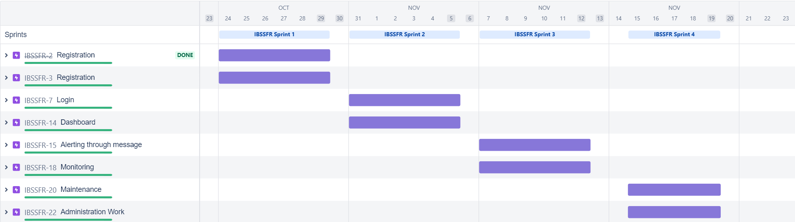

- CODING & SOLUTIONING
  - Feature 1

India railway is the most common means of transport. The tracks contract and expand due to changes in season. Due to this crack may develop on the track. The proposed system has the ability to detect the cracks and techniques which include low cost, low power consumption, fast detecting system without human intervention and less analysis time.

  - Feature 2

Railway login, booking, cancellation, and PNR generation through our python code developed with an objective to enable single window access to information and service. This will really help the user to easily handle i.e. user-friendly and very efficient.

  - Coding

import pickle
import sys
import random
class train:
def __init__(self,name = '', num = 0, arr_time = '',dep_time = '',src = '' ,des = '',day_of_travel = '',seat_available_in_1AC = 0,seat_available_in_2AC = 0,seat_available_in_SL = 0,fare_1ac = 0, fare_2ac = 0 ,fare_sl = 0):
self.name = name
self.num = num
self.arr_time = arr_time
self.dep_time = dep_time
self.src = src
self.des = des
self.day_of_travel = day_of_travel
self.seats = {'1AC' : seat_available_in_1AC, '2AC': seat_available_in_2AC,'SL': seat_available_in_SL}
self.fare = {'1AC' : fare_1ac,'2AC' : fare_2ac ,'SL' : fare_sl}
def print_seat_availablity(self):
print("No. of seats available in 1AC :- "+str(self.seats['1AC']))
print("No. of seats available in 2AC :- "+str(self.seats['2AC']))
print("No. of seats available in SL :- "+str(self.seats['SL']))
def check_availabilty(self,coach='',ticket_num = 0):
coach = coach.upper()
if coach not in ('SL','1AC','2AC'):
print_seat_availablity()
coach = input("Enter the coach(1AC/2AC/SL) :-")
else:
if self.seats[coach] == 0:
return False
elif self.seats[coach] >= ticket_num:
return True
else:
return False
def book_ticket(self,coach = '',no_of_tickets = 0):
self.seats[coach] -= no_of_tickets
return True
class user:
def __init__(self,uid = 0,name = '',hometown = '',cell_num = '',pwd = ''):
self.uid = uid
self.name = name
self.hometown = ''
self.cell_num = ''
self.pwd = pwd
self.history = {}
# def book_ticket(self)
class ticket:
def __init__(self,train,user,ticket_num):
self.pnr = str(train.num)+str(user.uid)+str(random.randint(100,999))
self.train_name = train.name
self.user_name = user.name
self.ticket_num = ticket_num
user.history.update({self.pnr : self})
ticket_dict.update({self.pnr : self})
def book_ticket():
try:
uid = int(input("Enter your User ID = "))
except ValueError:
print("\nEnter valid User ID\n")
book_ticket()
pwd = input("Enter your password :- ")
if uid in users and users[uid].pwd == pwd:
print("Welcome ",users[uid].name," !")
else:
print("\n\nNo such user ID / Wrong Password !\n\n")
menu()
check_seat_availabilty('p')
try:
choice = int(input("Enter the train number :- "))
except ValueError:
print("\n\nPlease properly enter the train number.\n\n")
menu()
book_ticket()
if choice in trains:
trains[choice].print_seat_availablity()
else:
print("\n\nEnter valid train number\n\n")
menu()
coach = input("Enter the coach :- ")
coach = coach.upper()
if coach in ('SL','1AC','2AC'):
ticket_num = int(input("Enter the number of tickets :- "))
if trains[choice].check_availabilty(coach,ticket_num):
prompt = input("Confirm Ticket(s) (y/n) ? :- ")
if prompt == 'y':
trains[choice].book_ticket(coach,ticket_num)
print("Booking Successful!\n\n")
tick = ticket(trains[choice],users[uid],ticket_num)
print("Please note PNR number :- ",tick.pnr,"\n\n")
menu()
else:
print("Exiting...\n\n")
menu()
else:
print(ticket_num," tickets not available")
menu()
else:
print("\n\nEnter proper coach\n\n")
menu()
def cancel_ticket():
pnr = input("Enter the PNR number :- ")
if pnr in ticket_dict:
check_pnr(pnr)
choice = input("Do you want to cancel(y/n):- ")
if choice == 'y':
uid = int(input("Enter your id :- "))
pwd = input("Enter the password :- ")
if uid in users:
if users[uid].pwd == pwd:
print("\n\nTicket Cancelled.\n\n")
else:
print("\nEnter the right password\n")
else:
print("\nNo such user.Ticket not cancelled\n")
menu()
else:
print("\nTicket not cancelled\n")
menu()
menu()
def check_seat_availabilty(flag = ''):
src = input("Enter the source station:- ")
des = input("Enter the destination station:- ")
flag_2 = 0
for i in trains:
if trains[i].src == src and trains[i].des == des:
print("Train Name :- ",trains[i].name ," " ,"Number ",trains[i].num ," ","Day of Travel :- ",trains[i].day_of_travel)
flag_2 += 1
if flag_2 == 0:
print("\n\nNo trains found between the stations you entered.\n\n")
menu()
if flag == '':
choice = int(input("Enter the train number :- "))
trains[choice].print_seat_availablity()
menu()
else:
pass
def check_pnr(pnr_num = ''):
if pnr_num == '':
pnr_num = input("Enter the PNR number :- ")
if pnr_num in ticket_dict:
print("User name:- ",ticket_dict[pnr_num].user_name)
print("Train name:- ",ticket_dict[pnr_num].train_name)
print("No. of Tickets Booked :- ",ticket_dict[pnr_num].ticket_num)
else:
print("\nNo such PNR number exists.\n")
# menu()
def create_new_acc():
user_name = input("Enter your user name:- ")
pwd = input("Enter your password :- ")
uid = random.randint(1000,9999)
hometown = input("Enter your hometown :- ")
cell_num = input("Enter your phone number :- ")
u = user(uid, user_name, hometown, cell_num, pwd)
print("Your user ID is :- ",uid)
users.update({u.uid : u})
menu()
t1 = train('odisha',12345,'12:34','22:12','ctc','kgp','Wed',30,23,43,2205,320,234)
t2 = train('howrah',12565,'02:34','23:12','hwr','kol','Mon',33,4,12,3434,435,234)
t3 = train('bangalore',22353,'11:56','03:12','ctc','ban','Fri',33,24,77,455,325,533)
trains = {t1.num:t1,t2.num:t2,t3.num:t3}
# trains.update({int(input("Enter the train number=")) : train(input("Enter the train name="),34353,'12:34','11:52','Wed',11,35,76)})
# print(train_dict[12565].name)
u1 = user(1212,'dibya das','cuttack','7478021777','dibyadas')
users={u1.uid : u1}
ticket_dict = {}
# train_file = open("t.pkl",'wb')
# user_file = open("u.pkl",'wb')
# pickle.dump(trains,train_file)
# pickle.dump(users,user_file)
# train_file.close()
# user_file.close()
# train_file = open("t.pkl","rb")
# user_file = open("u.pkl","rb")
# trains = pickle.load(train_file)
# users = pickle.load(user_file)
# train_file.close()
# user_file.close()
print("--------------------------------------------------Welcome to Railway Reservation Portal----------------------------------------------")
print("-------------------------------------------------------------------------------------------------------------------------------------")
def menu():
print("Choose one of the following option:-")
print("1.Book Ticket")
print("2.Cancel Ticket")
print("3.Check PNR ")
print("4.Check seat availibity")
print("5.Create new account")
print("6.Check previous transaction")
try:
option = int(input("Option = "))
except ValueError:
print("\n\nPlease enter a valid option.\n\n")
menu()
if option == 1:
book_ticket()
elif option == 2:
cancel_ticket()
elif option == 3:
check_pnr()
elif option == 4:
check_seat_availabilty()
elif option == 5:
create_new_acc()
menu()

- TESTING

Acceptance Testing
UAT Execution & Report Submission

Date | 12-Nov-22
Team ID | PNT2022TMID01080
Project Name | Smart solutions for railways
Maximum Marks | 4 Marks

Purpose of Document
The purpose of this document is to briefly explain the test coverage and open issues of the smart solutions for railways project at the time of the release to User Acceptance Testing (UAT).

Defect Analysis
This report shows the number of resolved or closed bugs at each severity level, and how they were resolved
Resolution | Severity 1 | Severity 2 | Severity 3 | Severity 4 | Subtotal
Dashboard | 1 | 0 | 3 | 0 | 4
Mobile App or website | 9 | 4 | 0 | 2 | 15
Duplicate sensors | 10 | 4 | 2 | 3 | 19
External wire | 2 | 3 | 3 | 6 | 14
Fixed communication | 11 | 2 | 4 | 15 | 32
Internet connection | 8 | 4 | 4 | 0 | 16
Totals | 41 | 17 | 16 | 26 | 100

Test Case Analysis
This report shows the number of test cases that have passed, failed, and untested
Section | Total Cases | Not Tested | Fail | Pass
Login page details | 7 | 0 | 0 | 7
Create Login page | 10 | 0 | 0 | 10
Enter passenger details | 10 | 0 | 0 | 10
Submit ticket details | 8 | 0 | 0 | 8
Generate QR code | 9 | 0 | 0 | 9
Scan QR code | 7 | 0 | 0 | 7
Check the entered details | 6 | 0 | 0 | 6
Dashboard in train (Pilot ) | 8 | 0 | 0 | 8
Check rail details (Pilot ) | 6 | 0 | 0 | 6
Location of the train in rail (Control Room) | 5 | 0 | 0 | 5
Check issue in the rail (Control Room) | 6 | 0 | 0 | 6
Locate the crack in rail (Control Room) | 7 | 0 | 0 | 7
Detect the type of crack (Control Room) | 5 | 0 | 0 | 5
Communicate with the pilot (Control Room) | 9 | 0 | 0 | 9

JIRA WORK:

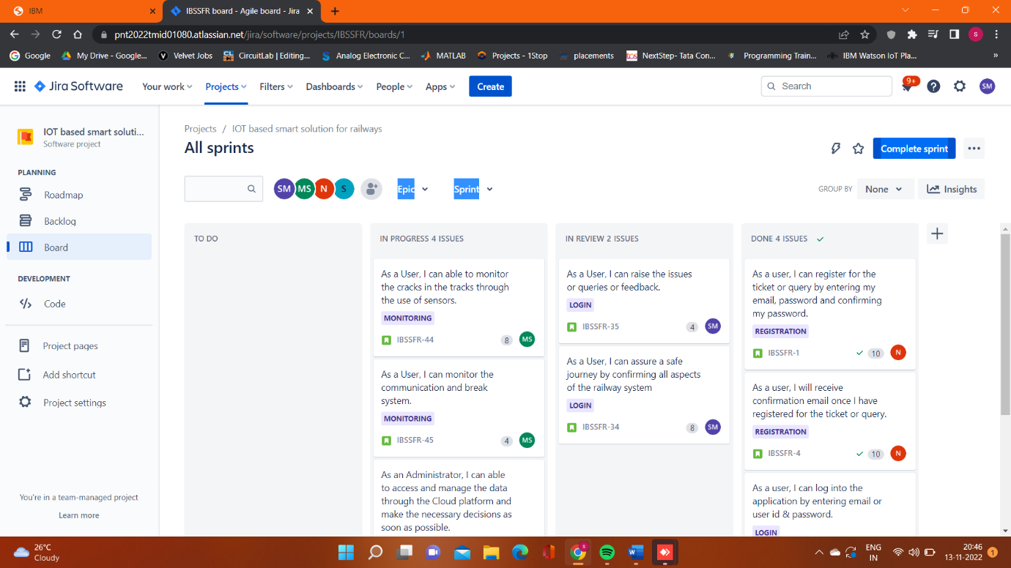

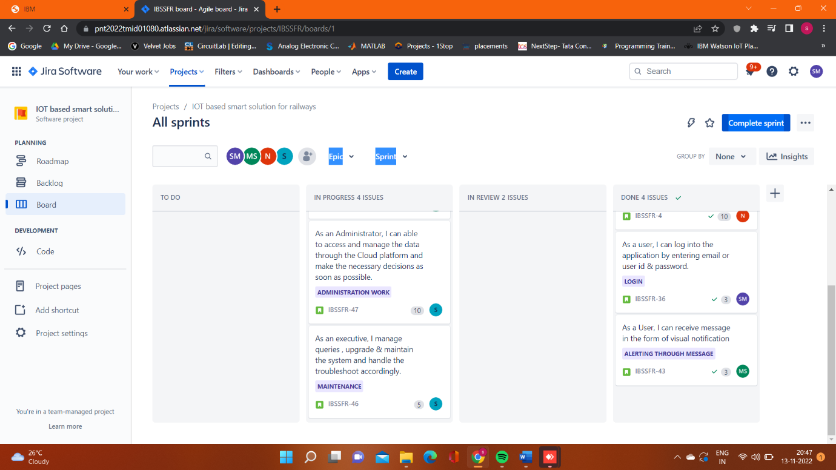

  - User Acceptance Testing
 |  |  |  | Date | 12-Nov-22
 |  |  |  | Team ID | PNT2022TMID01080
 |  |  |  | Project Name | Smart solutions for railways
 |  |  |  | Maximum Marks | 4 marks
 | Feature Type | Component | Test Scenario | Pre-Requisite | Steps To Execute | Test Data | Expected Result | Actual Result | Status | Commnets | TC for Automation(Y/N) | BUG ID | Executed By
  Test case ID
LoginPage_TC_OO1 | Functional | Home Page | Verify user is able to see the Login/Signup popup when user clicked on My account button | Need internet connection . Need a web page to use the url. | 1.Enter URL and click go.  2.Click on My Account dropdown button.  3.Verify login/Singup popup displayed or not. | https://TrainTicketBooking.com/ | Login/Signup popup should display | Working as expected | Pass |  | yes |  | User
LoginPage_TC_OO2 | UI | Home Page | Verify the UI elements in Login/Signup popup | Need internet connection . Need a web page to use the url. | 1.Enter URL and click go.  2.Click on My Account dropdown button.  3.Verify login/Singup popup with below UI elements:  a.email text box  b.password text box  c.Login button  d.New customer? Create account link  e.Last password? Recovery password link | https://TrainTicketBooking.com/ | Application should show below UI elements:  a.email text box  b.password text box  c.Login button with orange colour  d.New customer? Create account link  e.Last password? Recovery password link | Working as expected | Fail | Steps are not clear to follow | no | BUG-1234 | User
LoginPage_TC_OO3 | Functional | Home page | Verify user is able to log into application with Valid credentials | Need internet connection . Need a web page use the url. | 1.Enter URL(https://TrainTicketBooking.com/) and click go.  2.Click on My Account dropdown button.  3.Enter Valid username/email in Email text box.  4.Enter valid password in password text box.  5.Click on login button. | Username: moni@gmail.com  password: Test123 | User should navigate to user account homepage | Working as expected | Pass |  | yes |  | User
LoginPage_TC_OO4 | Functional | Login page | Verify user is able to log into application with InValid credentials | Need internet connection . Need a web page to use the url. | 1.Enter URL(https://TrainTicketBooking.com/) and click go.  2.Click on My Account dropdown button.  3.Enter InValid username/email in Email text box.  4.Enter valid password in password text box.  5.Click on login button. | Username: moni@gmail.com  password: Test123 | Application should show 'Incorrect email or password ' validation message. | Working as expected | Pass |  | yes |  | User
LoginPage_TC_OO4 | Functional | Login page | Verify user is able to log into application with InValid credentials | Need internet connection . Need a web page to use the url. | 1.Enter URL(https://TrainTicketBooking.com/) and click go.  2.Click on My Account dropdown button.  3.Enter Valid username/email in Email text box.  4.Enter Invalid password in password text box.  5.Click on login button. | Username: moni@gmail.com  password: Test123 | Application should show 'Incorrect email or password ' validation message. | Working as expected | Pass |  | yes |  | User
LoginPage_TC_OO5 | Functional | Login page | Verify user is able to log into application with InValid credentials | Need internet connection . Need a web page to use the url. | 1.Enter URL(https://TrainTicketBooking.com/) and click go.  2.Click on My Account dropdown button.  3.Enter InValid username/email in Email text box.  4.Enter Invalid password in password text box.  5.Click on login button. | Username: Monica  Password: Test123 | Application should show 'Incorrect email or password ' validation message. | Working as expected | Pass |  | yes |  | User
 | Functional | Main page | Enter the personal information .such as name , age, phone number and id proof. | Need internet connection . Need a web page to use the url. | 1. Enter the name . 2. Enter the age . 3.enter the phone number . 4.enter the ID proof . 5.go to next options . | Name : Monica.s Age: 21 Phone number : 9517532584 ID proof : Aadhar card |  | Working as expected | pass |  | yes |  | User
  LoginPage_TC_006
LoginPage_TC_007 | Functional | Main page | Enter the personal information .such as name , age, phone number and id proof. | Mobile app or web portal | 1. Enter the name . 2. Enter the age . 3.enter the phone number . 4.enter the ID proof . 6.pop up should come whether the entered data is valid / invalid . 5.go to next options . | Name : Monica.s Age: 21 Phone number : 9517532584 ID proof : Aadhar card | Valid information or Invalid information . | working as expected | Fail | The entered data is wrong. | no | BUG-4567 | User
LoginPage_TC_008 | Functional | Main page | Select the boarding station and destionation station | Mobile app or web portal | 1.enter the boarding station. 2.enter the destination station. | Boarding station : Chennai Deastination station : Banglore | Valid information or Invalid information . | Working as expected | Pass |  | yes |  | User
LoginPage_TC_009 | Functional | Main page | Select the seat number | Mobile app or web portal | 1.select the seat number. 2.select the coach number. | Seat number : 10 Coach number :S1 | Valid information or Invalid information . | Working as expected | Pass |  | yes |  | User
LoginPage_TC_010 | Functional | Output page | Submit the form . QR code will be generated | Mobile app or web portal | 1.QR will be generated. | QR code | QR code is vaild or invalid . | Working as expected | Pass |  | yes |  | User
LoginPage_TC_011 | Functional | Output page | Scan the QR code to check the entered information. | Mobile app or web portal or scanner of QR code | 1.Scan QR code. | QR code | QR code is vaild or invalid . | Working as expected | Fail | Scanned QR code is invalid | no | BUG-8910 | User
LoginPage_TC_012 | Functional | Display on train dash board | Verfiy pilot of the train , whether he can check the ststus of thr rail. | Indication in the dashboard | 1.check the display in the dashboard. 2. check whether there is any issue in the track. 3. if yes , look into the type of crack . | Display regarding the rail . | Status of rail . In case of issue then type of issue. | Working as expected | pass |  | yes |  | Pilot of the train
LoginPage_TC_013 | Functional | Display on train dash board | Verfiy pilot of the train , whether he can check the ststus of thr rail. | Indication in the dashboard | 1.check the display in the dashboard. 2. check whether there is any issue in the track. 3. if yes , look into the type of crack. 4. popup : error in the signal , error in the sensor , error in the wire, etc . | Display regarding the rail . | Status of rail . In case of issue then type of issue . | Working as expected | Fail | Signal lost or damage of sensors or problem in wiring | no | BUG-1112 | Pilot of the train
LoginPage_TC_014 | Functional | Display on Control board | Verfiy control room of the train , whether he can check the ststus of thr rail. | Indication in the dashboard | 1.check the display . 2.Check the trains travelling in the particular rail. 3.check the type of crack that has occurred . 4.take decision accordingly . | Display regarding the rail and the train travelling in that route . | Status of rail . Trains travelling in that rail . In case of issue then type of issue . | Working as expected | pass |  | yes |  | Control Room
LoginPage_TC_015 | Functional | Display on Control board | Verfiy control room of the train , whether he can check the ststus of thr rail. | Indication in the dashboard | 1.check the display 2.Check the trains travelling in the particular rail. 3.check the type of crack that has occurred . 4.take decision accordingly . 5.popup : error in the signal , error in the sensor , error in the wire, etc . | Display regarding the rail and the train travelling in that route . | Status of rail. Trains travelling in that rail . In case of issue then type of issue . | Working as expected | Fail | Failed to track the train or signal lost or communication error or damage of sensors. | no | BUG-1213 | Control Room

- ADVANTAGES & DISADVANTAGES
ADVANTAGES
- Its application increases safety, efficiency and ease of use with train management systems.
- Control and surveillance systems reduce the risk of collisions and regulate speed.
- Advanced consumer technologies help maximize connectivity and allow passengers to continue their activities on smart devices while travelling
- Greater Reliability and Safety
- Fewer Maintenance Delays
- Advanced Analytics for Streamlined Operations
- Restructured and Optimized Passenger Experience
- Better Product Development in the Industry

DISADVANTAGES:
- Internet must be available to all.
- Disadvantages in the hands of how we use it.

- CONCLUSION
“It’s the beginning of machines taking over the world”. So, we tend to use technology as great as possible. IoT is rightfully regarded as one of the most promising digital technologies that will definitely become more widespread and useful in the nearest future. Even at the current state, the capabilities of IoT solutions are impressive, and their advantages are tempting. However, it is important to realize that the integration of IoT in smart railways solutions and skills in order to achieve those benefits without suffering from its drawbacks.
- FUTURE SCOPE
It is expected to rely on smart transportation systems and interconnected solutions such as predictive maintenance. 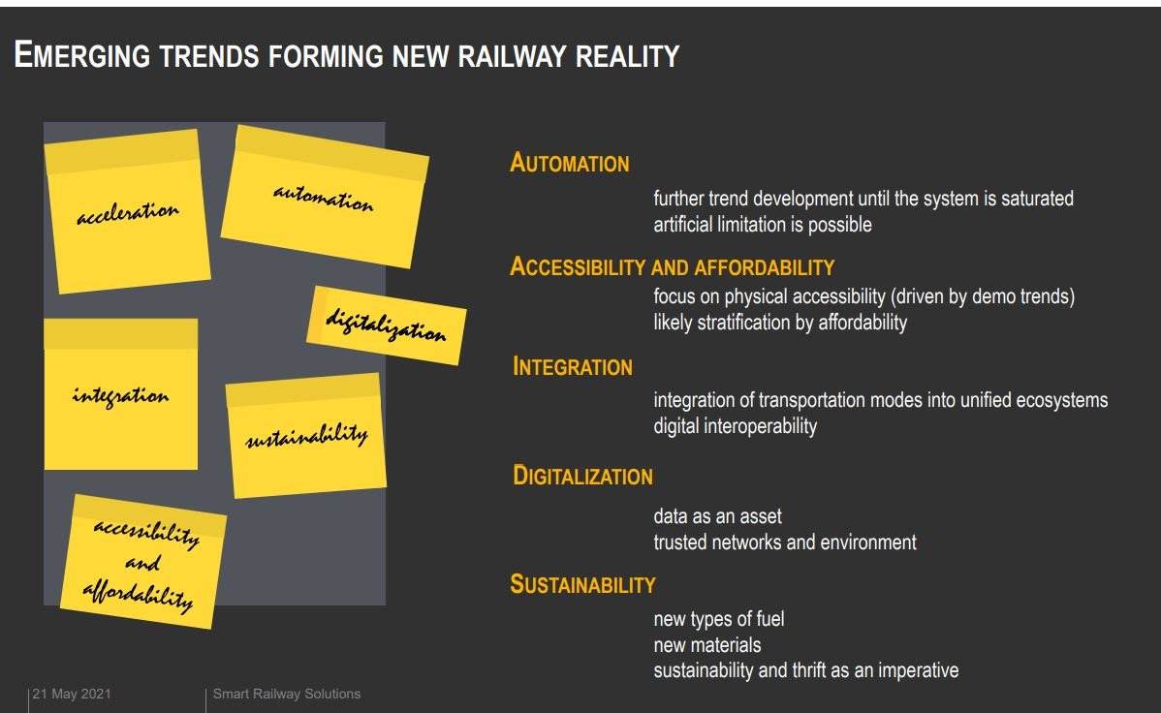

13.APPENDIX

Source code

import pickle
import sys
import random
class train:
def __init__(self,name = '', num = 0, arr_time = '',dep_time = '',src = '' ,des = '',day_of_travel = '',seat_available_in_1AC = 0,seat_available_in_2AC = 0,seat_available_in_SL = 0,fare_1ac = 0, fare_2ac = 0 ,fare_sl = 0):
self.name = name
self.num = num
self.arr_time = arr_time
self.dep_time = dep_time
self.src = src
self.des = des
self.day_of_travel = day_of_travel
self.seats = {'1AC' : seat_available_in_1AC, '2AC': seat_available_in_2AC,'SL': seat_available_in_SL}
self.fare = {'1AC' : fare_1ac,'2AC' : fare_2ac ,'SL' : fare_sl}
def print_seat_availablity(self):
print("No. of seats available in 1AC :- "+str(self.seats['1AC']))
print("No. of seats available in 2AC :- "+str(self.seats['2AC']))
print("No. of seats available in SL :- "+str(self.seats['SL']))
def check_availabilty(self,coach='',ticket_num = 0):
coach = coach.upper()
if coach not in ('SL','1AC','2AC'):
print_seat_availablity()
coach = input("Enter the coach(1AC/2AC/SL) :-")
else:
if self.seats[coach] == 0:
return False
elif self.seats[coach] >= ticket_num:
return True
else:
return False
def book_ticket(self,coach = '',no_of_tickets = 0):
self.seats[coach] -= no_of_tickets
return True
class user:
def __init__(self,uid = 0,name = '',hometown = '',cell_num = '',pwd = ''):
self.uid = uid
self.name = name
self.hometown = ''
self.cell_num = ''
self.pwd = pwd
self.history = {}
# def book_ticket(self)
class ticket:
def __init__(self,train,user,ticket_num):
self.pnr = str(train.num)+str(user.uid)+str(random.randint(100,999))
self.train_name = train.name
self.user_name = user.name
self.ticket_num = ticket_num
user.history.update({self.pnr : self})
ticket_dict.update({self.pnr : self})
def book_ticket():
try:
uid = int(input("Enter your User ID = "))
except ValueError:
print("\nEnter valid User ID\n")
book_ticket()
pwd = input("Enter your password :- ")
if uid in users and users[uid].pwd == pwd:
print("Welcome ",users[uid].name," !")
else:
print("\n\nNo such user ID / Wrong Password !\n\n")
menu()
check_seat_availabilty('p')
try:
choice = int(input("Enter the train number :- "))
except ValueError:
print("\n\nPlease properly enter the train number.\n\n")
menu()
book_ticket()
if choice in trains:
trains[choice].print_seat_availablity()
else:
print("\n\nEnter valid train number\n\n")
menu()
coach = input("Enter the coach :- ")
coach = coach.upper()
if coach in ('SL','1AC','2AC'):
ticket_num = int(input("Enter the number of tickets :- "))
if trains[choice].check_availabilty(coach,ticket_num):
prompt = input("Confirm Ticket(s) (y/n) ? :- ")
if prompt == 'y':
trains[choice].book_ticket(coach,ticket_num)
print("Booking Successful!\n\n")
tick = ticket(trains[choice],users[uid],ticket_num)
print("Please note PNR number :- ",tick.pnr,"\n\n")
menu()
else:
print("Exiting...\n\n")
menu()
else:
print(ticket_num," tickets not available")
menu()
else:
print("\n\nEnter proper coach\n\n")
menu()
def cancel_ticket():
pnr = input("Enter the PNR number :- ")
if pnr in ticket_dict:
check_pnr(pnr)
choice = input("Do you want to cancel(y/n):- ")
if choice == 'y':
uid = int(input("Enter your id :- "))
pwd = input("Enter the password :- ")
if uid in users:
if users[uid].pwd == pwd:
print("\n\nTicket Cancelled.\n\n")
else:
print("\nEnter the right password\n")
else:
print("\nNo such user.Ticket not cancelled\n")
menu()
else:
print("\nTicket not cancelled\n")
menu()
menu()
def check_seat_availabilty(flag = ''):
src = input("Enter the source station:- ")
des = input("Enter the destination station:- ")
flag_2 = 0
for i in trains:
if trains[i].src == src and trains[i].des == des:
print("Train Name :- ",trains[i].name ," " ,"Number ",trains[i].num ," ","Day of Travel :- ",trains[i].day_of_travel)
flag_2 += 1
if flag_2 == 0:
print("\n\nNo trains found between the stations you entered.\n\n")
menu()
if flag == '':
choice = int(input("Enter the train number :- "))
trains[choice].print_seat_availablity()
menu()
else:
pass
def check_pnr(pnr_num = ''):
if pnr_num == '':
pnr_num = input("Enter the PNR number :- ")
if pnr_num in ticket_dict:
print("User name:- ",ticket_dict[pnr_num].user_name)
print("Train name:- ",ticket_dict[pnr_num].train_name)
print("No. of Tickets Booked :- ",ticket_dict[pnr_num].ticket_num)
else:
print("\nNo such PNR number exists.\n")
# menu()
def create_new_acc():
user_name = input("Enter your user name:- ")
pwd = input("Enter your password :- ")
uid = random.randint(1000,9999)
hometown = input("Enter your hometown :- ")
cell_num = input("Enter your phone number :- ")
u = user(uid, user_name, hometown, cell_num, pwd)
print("Your user ID is :- ",uid)
users.update({u.uid : u})
menu()
t1 = train('odisha',12345,'12:34','22:12','ctc','kgp','Wed',30,23,43,2205,320,234)
t2 = train('howrah',12565,'02:34','23:12','hwr','kol','Mon',33,4,12,3434,435,234)
t3 = train('bangalore',22353,'11:56','03:12','ctc','ban','Fri',33,24,77,455,325,533)
trains = {t1.num:t1,t2.num:t2,t3.num:t3}
# trains.update({int(input("Enter the train number=")) : train(input("Enter the train name="),34353,'12:34','11:52','Wed',11,35,76)})
# print(train_dict[12565].name)
u1 = user(1212,'dibya das','cuttack','7478021777','dibyadas')
users={u1.uid : u1}
ticket_dict = {}
# train_file = open("t.pkl",'wb')
# user_file = open("u.pkl",'wb')
# pickle.dump(trains,train_file)
# pickle.dump(users,user_file)
# train_file.close()
# user_file.close()
# train_file = open("t.pkl","rb")
# user_file = open("u.pkl","rb")
# trains = pickle.load(train_file)
# users = pickle.load(user_file)
# train_file.close()
# user_file.close()
print("--------------------------------------------------Welcome to Railway Reservation Portal----------------------------------------------")
print("-------------------------------------------------------------------------------------------------------------------------------------")
def menu():
print("Choose one of the following option:-")
print("1.Book Ticket")
print("2.Cancel Ticket")
print("3.Check PNR ")
print("4.Check seat availibity")
print("5.Create new account")
print("6.Check previous transaction")
try:
option = int(input("Option = "))
except ValueError:
print("\n\nPlease enter a valid option.\n\n")
menu()
if option == 1:
book_ticket()
elif option == 2:
cancel_ticket()
elif option == 3:
check_pnr()
elif option == 4:
check_seat_availabilty()
elif option == 5:
create_new_acc()
menu()

GitHub:
https://github.com/IBM-EPBL/IBM-Project-2002-1658422646

Project Demo Link: (please copy paste the link in browser)
https://uploadnow.io/f/GyPmspN

